
Print a License Document

Before You Begin
Important! If this is the first time you’ve accessed the system, you must link your license before you can print the license document.
o See Create your user access to the Professional and Business Licensing System for detailed instructions.
You’ll have 3 options to generate your license:
- Self-print: Electronic document downloaded within minutes
- Email: Electronic document sent by email, received the next day
- Mail: Paper document sent by mail, usually received within 2 – 4 weeks o There is a $5 fee for each paper license You’ll begin by navigating to the appropriate license.
- To print a Professional license, start at Navigate to a Professional License.
- To print a Business license, start at Navigate to a Business License.

Navigate to a Professional License
- Click Professional Licenses link from the top menu of the Professional and Business Licensing Home page.
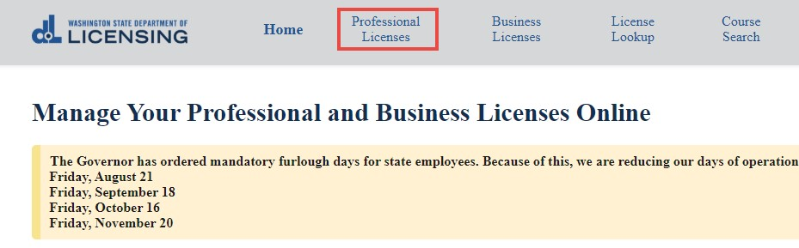

- Click the link for the license you want to print.
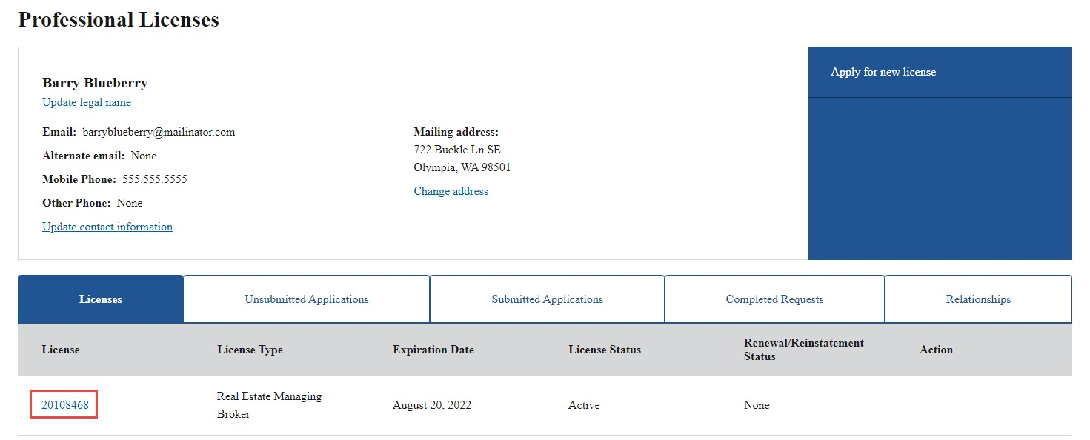
- Go to Select Delivery Method.

Navigate to a Business License
- Click Business Licenses link from the top menu of the Professional and Business Licensing Home page.
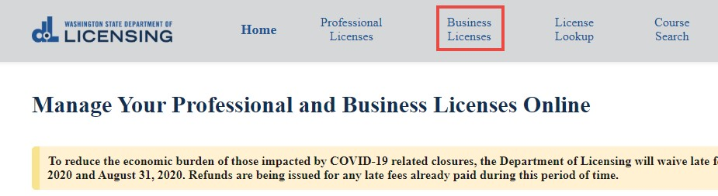

- Click link in tile for business you’re printing the license for.
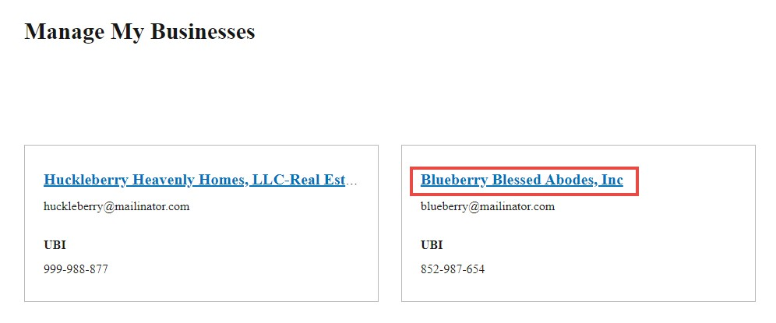
- Click the link for the license you want to print.
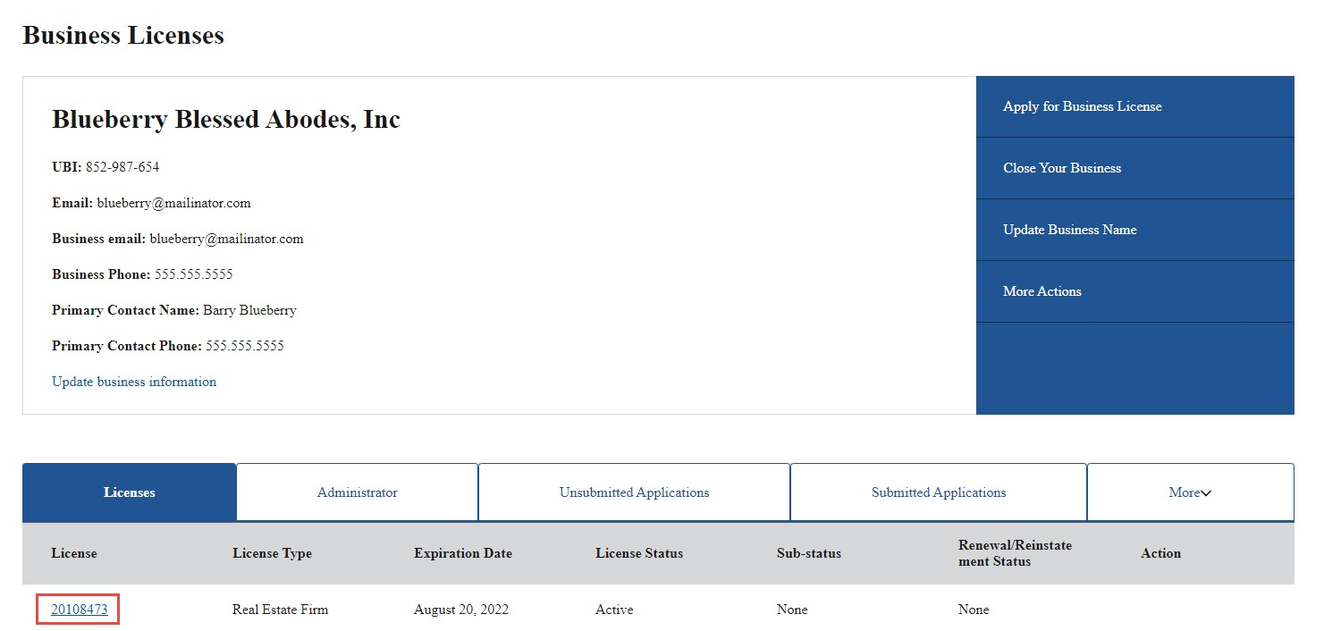
- Go to Select Delivery Method.

Select Delivery Method
- Click Print License from the right-hand menu on the license detail page.
  - Selection may appear in a different place within the menu.
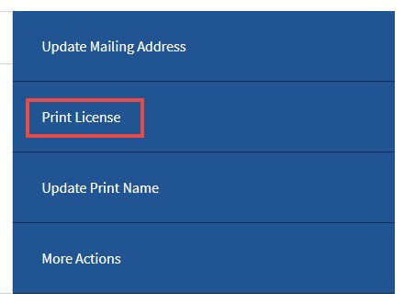
- Select the delivery method for the license from the dropdown and click Submit.
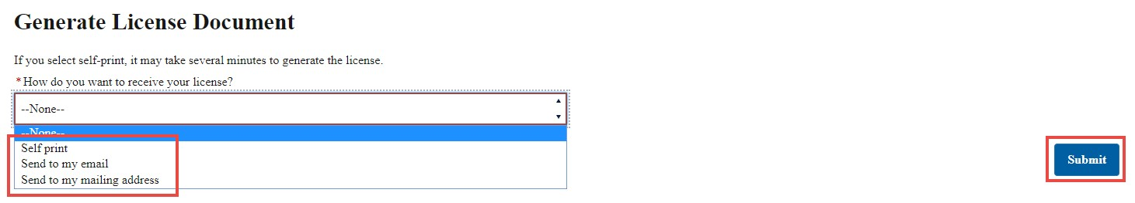
  - Self-print: Go to Self-Print License • Email: Click Ok at the pop-up.
o The next day, you’ll receive an email (sent to the email address on file) with the license document as a PDF attachment.
  - Mail: Go to Printed License

Self-Print License
- It will take 2-3 minutes to generate the license.
- Click the Proceed button at the pop-up.
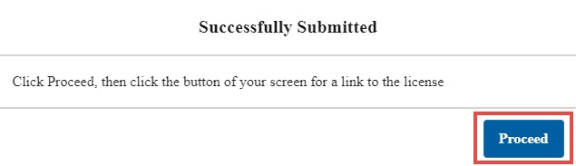
- The downloaded document link will appear in the lower left-hand corner of the screen.
  - It may take several moments before it appears.
  - If you don’t see a link, check the Downloads folder on your computer.


Printed License
- Enter the number of license copies you want to print and click Submit.
  - There is a $5 fee for each copy.
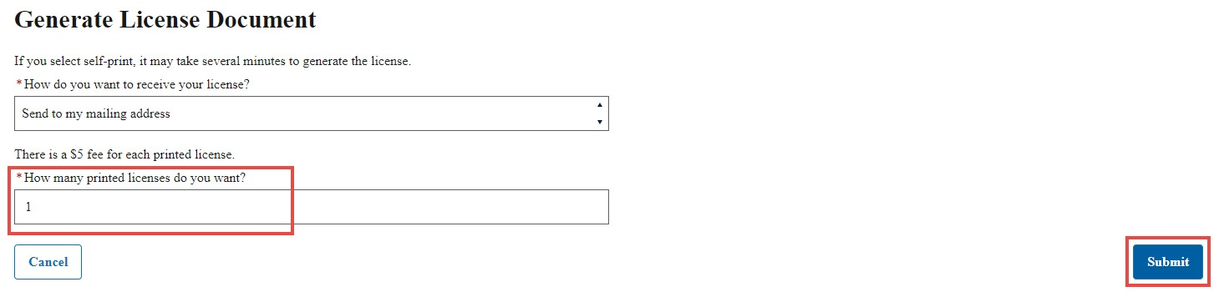

- Click Ok at the pop-up.
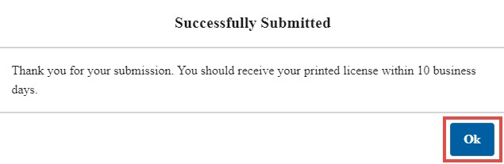
- Go through the all payment screens to pay for the license(s). Continue until you return to the portal page.
- The license(s) will be printed at the next printing cycle and mailed to the mailing address on file.
  - It may take 2-4 weeks to receive your printed license(s).

